SOA BPM NICE IEX

Automated Avaya Repost Installation

by

MMS NICE IEX Technical Team

December 23, 2016

**Installation Steps**

**Step 1: Create Directory for Batch Scripts on the NICE App Server**

Create this directory on the NICE App Server, if it doesn’t already exist

C:\maximus\NICE\scripts

**Step 2: Copy Batch Script Files to the NICE App Server**

Download:

svn://rcmxapp1d.maximus.com/maxdat/NICE/install/windows/

repost_Avaya_intervals_into_NICE.bat

repost_Avaya_intervals_into_NICE_acd.*.jmx

svn://rcmxapp1d.maximus.com/maxdat/NICE/alert/missed_Avaya_interval_alert.sql

To the NICE App Server at:

C:\maximus\NICE\scripts

**Step 3: Set the DB_USER DB_PASSWORD in the Batch File for the NICE SQL Server NICE db:**

Edit C:\maximus\NICE\scripts\ repost_Avaya_intervals_into_NICE.bat

Change:

DB_USER

DB_PASSWORD

To:

Username and password of NICE SQL Server user.

**Step 4: Setup the Scheduled Task**

Click the windows button in the bottom left corner and search for Task Scheduler. Right click on Task Scheduler and click “Create Task” from the menu.

Setup a new Scheduled task with the following properties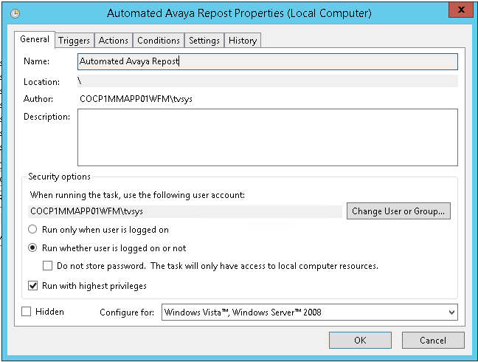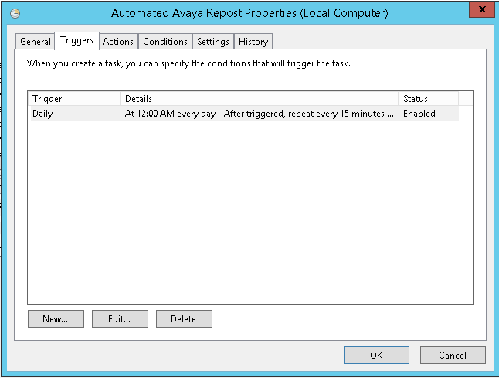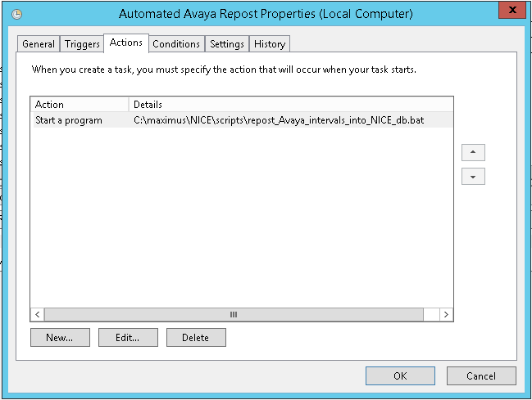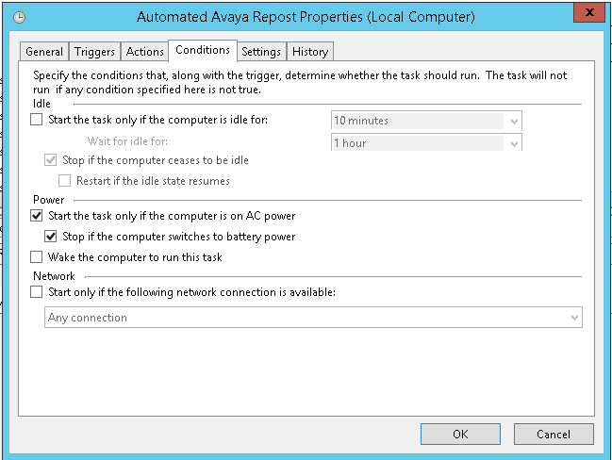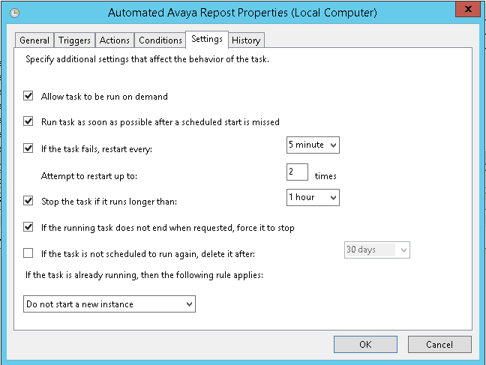

**Installation should be complete**